**SG-PTD4032NK-2T7T**

**- Thermal + Optical Bi-spectrum Network NDAA PTZ Dome Camera**

**- 256x192 Thermal 7mm Lens + 4MP 32x Zoom Starlight Network Camera Module**

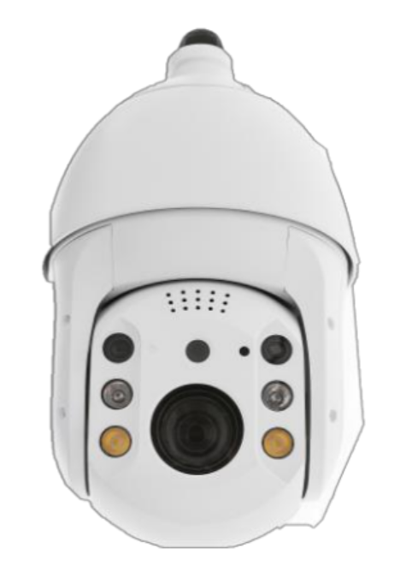

**1. Features**

> 1 Channel Thermal and Visible Video complex stream.

> One IP address for Main Control Chip, more stable than double IP version products.

> Horizontal 360° rotation, speed up to 0.1°~200°/S

> Vertical -10°~+90°, speed up to 0.1°~105°/S

> IR distance up to 120m

> IP66 Water proof

**Visible Camera**

> 1/2.9” Smartsens CMOS Sensor.

> Powerful 32x optical zoom (4.7~150mm).

> Max. 4Mp(2688x1520) Resolution

> Support various IVS functions

> Support Electronic Defog

> With NOVATEK high performance chip

**Thermal Camera**

> 256x192 Resolution, high sensitivity sensor

> 12μm Pixel pitch.

> 7mm Fixed Thermal Lens

> Support Temperature measurement function

**2. Specification**

|  |  |  |  |  |  |
| --- | --- | --- | --- | --- | --- |
| **Model** | | **SG-PTD4032NK-2T7T** | | | |
| **Thermal Camera** | | | | | |
| Sensor | Image Sensor | Uncooled VOx Microbolometer | | | |
| Resolution | 256 x 192 | | | |
| Pixel Size | 12μm | | | |
| Spectral Range | 8~14μm | | | |
| Lens | Focal Length | 7mm | | | |
| F Value | F1.0 | | | |
| Focus | Athermalized, Focus-free | | | |
| Angle of View | 24°x18° | | | |
| Video | Resolution | 50Hz: 25fps@(1280×1024, 1280×720)  60Hz: 30fps@(1280×1024, 1280×720) | | | |
| Pseudo color | Support: White Hot, Fulgurite, Iron Red, Hot Iron, Medical, Arctic, Rainbow 1, Rainbow 2, Tint | | | |
| IVS | | Tripwire, Cross Fence Detection, Intrusion | | | |
| Fire Detection | | Support | | | |
| Temperature | Temperature measurement measurement | Support | | | |
| Measurement Range | Low-T mode: -20℃~150℃,  High-T mode: 0℃~550℃ | | | |
| Measurement Accuracy | ±5℃ or ±5% (Take large values) | | | |
| Measurement Tools | Spots / Areas / Lines / Max. & Avg. & Min. Temp on screen Comparative analysis | | | |
| Actions | Tigger Relay out, Snapshot, Record, PTZ call, High & Low Temp track. | | | |
| **Visible Camera** | | | | | |
| Sensor | Image Sensor | 1/2.9" progressive scan Smartsens CMOS sensor | | | |
| Effective Pixels | Approx. 4.09 Megapixel | | | |
| Lens | Focal Length | 4.7mm~150mm, 32x Optical Zoom | | | |
| Aperture | F1.5~F4.0 | | | |
| Field of View | H: 59.5°~2.0°, V: 35.8°~1.1°, D: 66.6°~2.4° | | | |
| Close Focus Distance | 0.1m~1.5m (Wide~Tele) | | | |
| Zoom Speed | Approx.5.5s (Optical Wide~Tele) | | | |
| DORI Distance  (Human) | Detect | Observe | Recognize | Identify |
| 3,079m | 1,222m | 615m | 307m |
| Video | Compression | H.265/H.264/H.264H/MJPEG | | | |
| Streaming Capability | 3 streams | | | |
| Resolution | 50Hz: 25/50fps@4Mp(2688x1520)  60Hz: 30/60fps@4Mp(2688x1520) | | | |
| Video Bit Rate | 32kbps~16Mbps | | | |
| Audio | AAC / MP2L2 | | | |
| General Events | | Motion, Tamper, SD Card, Network | | | |
| IVS | | Tripwire, Cross Fence Detection, Intrusion, Abandoned Object, Fast-Moving, Parking Detection, Crowd Gathering Estimation, Missing Object, Loitering Detection. | | | |
| S/N Ratio | | ≥55dB (AGC Off, Weight ON) | | | |
| Minimum Illumination | | Color: 0.005Lux/F1.5; B/W: 0.0005Lux/F1.5 | | | |
| Noise Reduction | | 2D/3D | | | |
| Exposure Mode | | Auto, Aperture Priority, Shutter Priority, Gain Priority, Manual | | | |
| Exposure Compensation | | Support | | | |
| Shutter Speed | | 1/1~1/30000s | | | |
| BLC | | Support | | | |
| HLC | | Support | | | |
| WDR | | Support | | | |
| White Balance | | Auto, Manual, Indoor, Outdoor, ATW, Sodium lamp, Street lamp, Natural, One Push | | | |
| Day/Night | | Electrical, ICR(Auto/Manual) | | | |
| IR Distance | | Up to 120m | | | |
| Focus Mode | | Auto, Manual, Semi Auto, Fast Auto, Fast Semi Auto, One Push AF | | | |
| Electronic Defog | | Support | | | |
| Flip | | Support | | | |
| EIS | | Support | | | |
| Digital Zoom | | 16x | | | |
| **PTZ** | | | | | |
| Pan/Tilt Range | | Pan: 360°; Tilt: -10°~90° | | | |
| Pan Speed | | Configurable, pan: 0.1°~200°/s; | | | |
| Tilt Speed | | Configurable, pan: 0.1°~105°/s | | | |
| Presets | | 255 | | | |
| **General Function** | | | | | |
| Compression | | H.265/H.264/H.264H/MJPEG | | | |
| Storage Capabilities | | TF card (256 GB), FTP, NAS | | | |
| Network Protocol | | Onvif, HTTP, HTTPS, IPv4, IPv6, RTSP, DDNS, RTP, TCP, UDP | | | |
| Interoperability | | ONVIF, GB/T28181, CGI | | | |
| Interface | Power Interface | AC24 3A | | | |
| Ethernet | RJ45(10Base-T/100Base-TX) | | | |
| Audio I/O | 1/1 | | | |
| Alarm I/O | 1/2 | | | |
| RS485 | 1, support Pelco-D protocol | | | |
| Working Conditions | | -30°C~+60°C(<90%RH) | | | |
| Power Supply | | DC12V / 4A ±15%, PoE | | | |
| Power Consumption | | Max. 20W | | | |
| Protection Level | | IP66; TVS 4000V Lightning Protection, GB/T17626.5 | | | |
| Dimensions(L*W*H) | | Φ185 (mm)×352(mm) | | | |
| Weight | | 4kg | | | |

**3. Dimension**

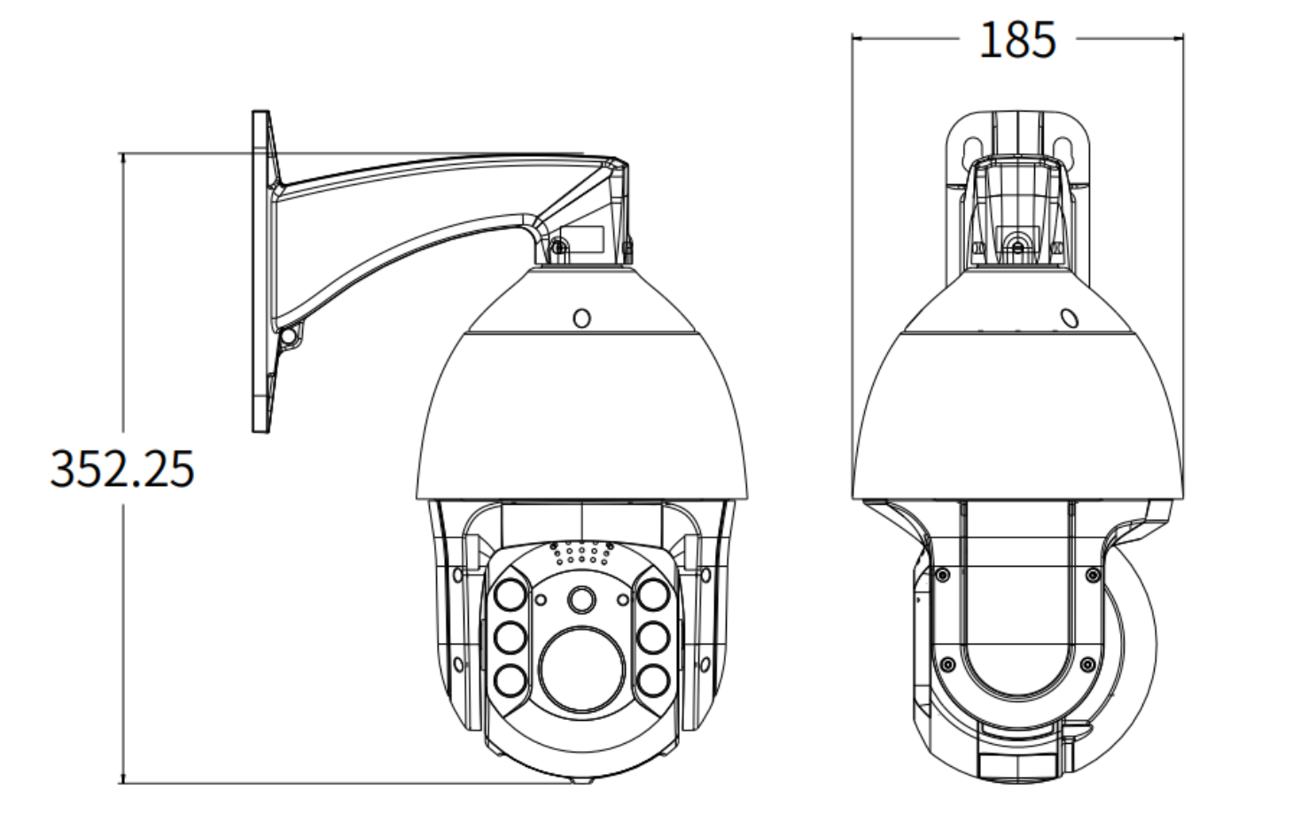

**Hangzhou Savgood Technology Co., Ltd.**

Rm. 701, Xincheng Fazhan Building #1, No. 406 Xintiandi Street,

Xiacheng District, Hangzhou City, 310004, China

Tel: +86 - (571) 8803 8121

Email: sales@savgood.com

<http://www.savgood.com>

<http://www.savgoodtech.com>

*Design and specifications are subject to change without prior notification.

© 2013 Savgood Technology Co., Ltd.